This chart shows the seasonally adjusted Unemployment Rate from January 2003 through June 2007. The rate was 5.8 percent in January 2003. It peaked at 6.3 percent in June 2003, and then it began an uneven but steady decline. By December 2003 it had dropped to 5.7 percent, below the level it was at in January of that year. The rate continued to decline till it reached a low of 4.4 percent in October 2006. It rose to 4.6 percent by January of 2007, but declined to 4.4 percent again by March 2007. The rate rose again to 4.5 percent for April, May and June of 2007. (The source is the Bureau of Labor Statistics.)
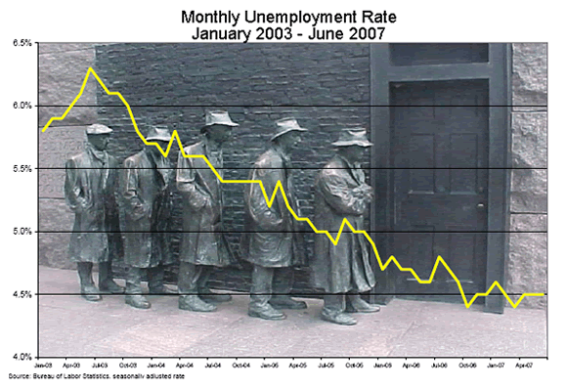
BLS Series LNS 14,000,000 Seasonal Unemployment Rate 16 years and over
Year | Jan | Feb | Mar | Apr | May | Jun | Jul | Aug | Sep | Oct | Nov | Dec
2003 | 5.8 | 5.9 | 5.9 | 6.0 | 6.1 | 6.3 | 6.2 | 6.1 | 6.1 | 6.0 | 5.8 | 5.7
2004 | 5.7 | 5.6 | 5.8 | 5.6 | 5.6 | 5.6 | 5.5 | 5.4 | 5.4 | 5.4 | 5.4 | 5.4
2005 | 5.2 | 5.4 | 5.2 | 5.1 | 5.1 | 5.0 | 5.0 | 4.9 | 5.1 | 5.0 | 5.0 | 4.9
2006 | 4.7 | 4.8 | 4.7 | 4.7 | 4.6 | 4.6 | 4.8 | 4.7 | 4.6 | 4.4 | 4.5 | 4.5
2007 | 4.6 | 4.5 | 4.4 | 4.5 | 4.5 | 4.5

