Occupation Research – Prezi Presentation Directions and Rubric
Using online resources, research a career of your choice and answer the following questions in detail/paragraph form on notebook paper first. You must turn in your answers before beginning to create your Prezi. The teacher will return your paper after reviewing it. You will use the information you discover to create an online presentation in Prezi to share with the class. The Prezi must include all information from questions below. We will discuss and practice how to create a presentation in Prezi.
- What do people in this career do? What are the duties and responsibilities?
- What is the work environment like? Where do they work—at a desk, outside? Safety procedures or concerns?
- What kind of education and/or training do you need to become a ____________?
- How much money can you make? What is the starting salary? What is the national average? With experience, how much money could you make? Compare the national average to Alabama’s average salary in the same career.
- What does the future look like for this job? What is the expected growth—good or bad? What is the percentage?
- Find one more interesting fact or some information you would like to share that you discovered in your research about this career.
Here are the resources:
O*Net: http://www.onetoline.org/
Alabama Department of Labor: http://www2.dir.alabama.gov/WorkforceDev/CareerExploration/Default2apsx
Occupational Outlook Handbook—Bureau of Labor of Statistics: http://www.bls.gov/ooh/.
(A hard copy of the Occupational Outlook Handbook can be found in your local library.)

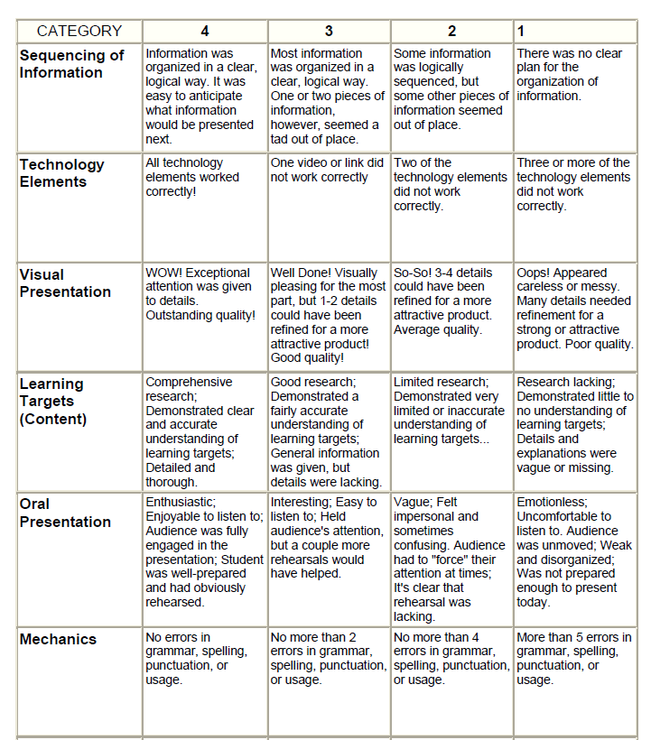
PREZI RUBRIC

